CL 2006 OPERATING SYSTEM

BS Software Engineering
Spring-2026

Course Instructors: Syed Daniyal Hussain Shah, Hifza Umar




Lab 14: Binary Semaphores

A binary semaphore is a synchronization primitive used to manage access to shared resources in a multi-threaded or multi-process environment. It has two possible states:
- 0 (Locked/Unavailable): The resource is currently being used.
- 1 (Unlocked/Available): The resource is free for access.
Binary semaphores are often used to implement mutual exclusion (mutex), ensuring that only one thread or process can access a critical section at a time.

Example Analogy:
Imagine a single restroom in an office building:
- The restroom can either be occupied (0) or free (1).
- A binary semaphore acts as a key:
  - If a person (thread) wants to use the restroom, they check if the key (semaphore) is available (1).
  - If it’s free, they take the key (lock it to 0) and enter.
  - When done, they return the key (unlock it to 1), signaling others that the restroom is now available.

Key Functions in Binary Semaphore Implementation:
- wait() (P operation): Decreases the semaphore value.
  - If the semaphore is 1, it changes to 0, granting access to the resource.
  - If the semaphore is 0, the thread is blocked until the semaphore becomes 1.
- signal() (V operation): Increases the semaphore value.
  - If the semaphore is 0, it changes to 1, signaling that the resource is now available.

Binary Semaphore in Programming
Here’s how a binary semaphore works in a multi-threaded program:

Binary Semaphore Functions in Programming

sem_init
Initializes the semaphore.
Syntax: int sem_init(sem_t *sem, int pshared, unsigned int value);
- sem: Pointer to the semaphore.
- pshared: 0 for thread-level sharing, non-zero for process-level sharing.
- value: Initial value of the semaphore (0 or 1 for binary semaphores).
Return Value:
Returns 0 on success, -1 on error.

sem_wait
Decrements the semaphore value. If the value is 0, it blocks the thread until the semaphore is incremented by another thread.
int sem_wait(sem_t *sem);

sem_post
Increments the semaphore value, signaling other threads waiting on the semaphore to proceed.
Syntax:
int sem_post(sem_t *sem);

sem_destroy
Destroys the semaphore.
Syntax:
int sem_destroy(sem_t *sem);

Examples : A binary semaphore demonstrating mutual exclusion, where two threads attempt to access a shared resource (a critical section), but the semaphore ensures that only one thread can access it at a time.
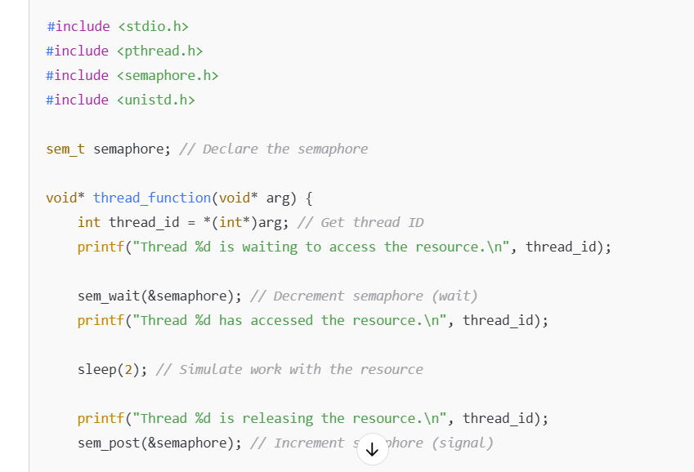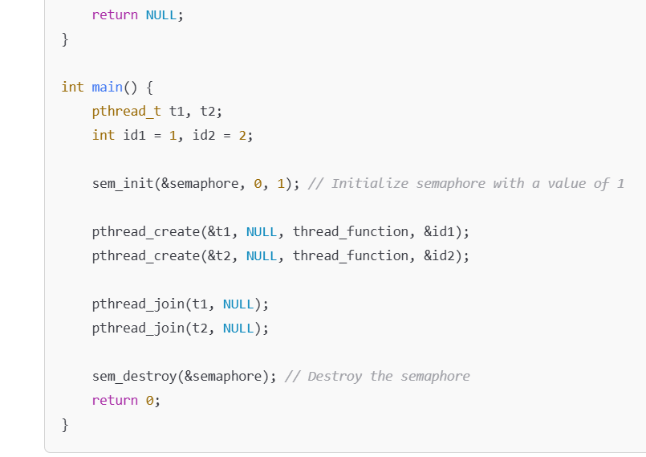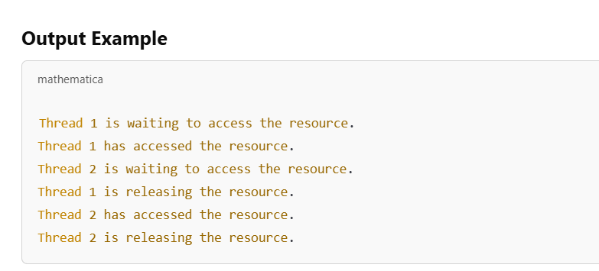
- Thread 1 accesses the resource first while Thread 2 waits for the semaphore to be released.
- Once Thread 1 releases the resource, Thread 2 accesses it.

Tasks:

Task 1: Basic Semaphore Synchronization (20 mins)
Description:
Create a program where two threads attempt to print a message alternately. Use a binary semaphore to ensure that only one thread prints at a time.
Hint:
- Use sem_wait and sem_post to control the printing order.
- Initialize the semaphore so that one thread starts first.

Task 2: Producer-Consumer Problem Using Binary Semaphore (25 mins)
Description:
Create a program that simulates a producer and a consumer using binary semaphores.
- The producer thread generates a random number and "produces" it.
- The consumer thread "consumes" the number after it is produced.
- Use a binary semaphore to ensure the consumer waits until the producer produces a number.
Hint:
- Use sem_wait for the consumer to block until the producer signals.
- Use sem_post for the producer to signal the consumer.

Task 3: Threaded Summation Using Semaphore (30 mins)
Description:
Create a program where:
- An array is passed to multiple threads, each responsible for calculating the sum of a segment of the array.
- Use a binary semaphore to ensure only one thread updates the shared total sum variable at a time.
- The main function should display the total sum after all threads complete their calculations.
Hint:
- Use sem_wait to lock the shared total sum variable during updates.
- Use sem_post to unlock after the update

Task 4: Finding the Minimum Value with Semaphore Protection (20 mins)
Description:
Create a program where multiple threads search different segments of an array for the minimum value.
- Use a binary semaphore to ensure only one thread updates the shared minimum value variable at a time.
- The main function should display the minimum value after all threads complete.
Hint:
- Use sem_wait to lock the shared minimum value variable during updates.
- Use sem_post to unlock after the update.

Task Submission Guidelines:
- Make a document and paste all tasks solution there (Not screenshot) and save it as pdf.
- Along with each task solution, also upload the screenshot of the output.
- Include your name and roll no. at the front page.
- Please submit your file in this format (Roll_number-name) i.e (24I-1234-Ali.pdf).
- Files other than pdf will not be accepted and will be marked as 0.

